Laboratory work №10
Text visualization with tex/latex

Tasks
To perform this task, it is recommended to use web platform Overleaf (https://www.overleaf.com). You can use templates form https://www.overleaf.com/latex/templates.
Task 1. Create your own resume (CV) using tex/latex. The resume (CV) should contain the following sections:
1. Full name, contact information, photo
2. Education
3. Experience
4. Technologies
5. Publications
6. Other achievements.
Task 2. Create report, which contains all results and short comment for laboratory work 9 (nonlinear dimension reduction) or 10 (linear dimension reduction)

- Resume (CV) using tex/latex.
For CV using A Customised CurVe CV template. Don’t have Publications and Experience.
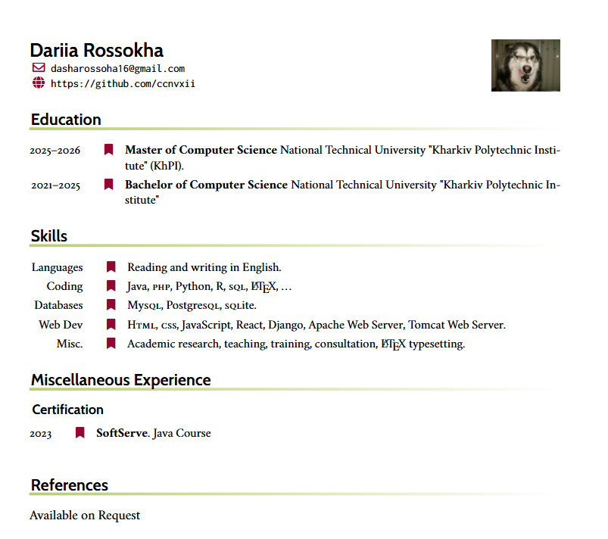
Figure 1 – CV

- Report, which contains all results and short comment for laboratory work 9.
For report using Chimera 2025 Abstract template.
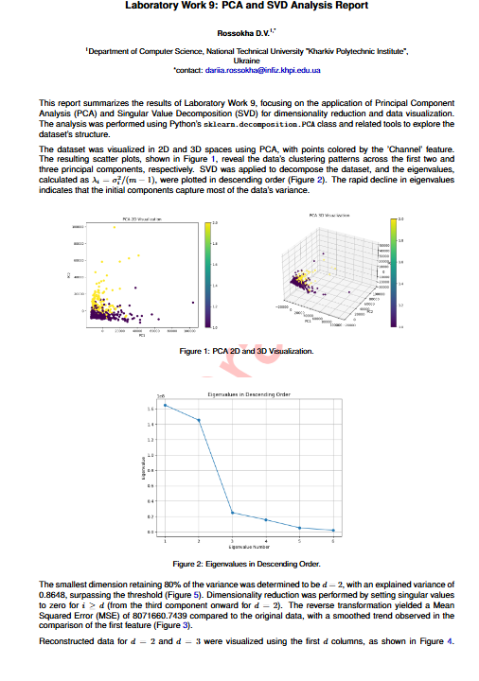
Figure 2 – Report Lab9

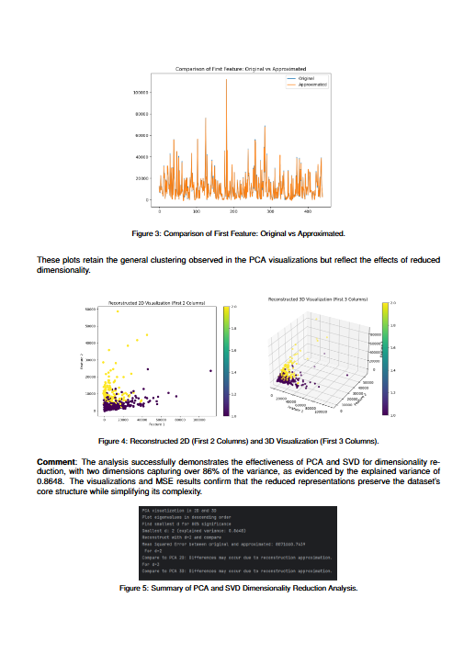
Figure 3 – Report Lab9

